Claims Conference  February 23-24, 2016 | Westin Westminster | Denver, CO | 2016
Dear Speaker,
Thank you for taking the time to complete this speaker proposal for the NAMIC Claims Conference. This form is a tool used to gather potential speaker names, session content, and other important details as we work to develop the curriculum for the 2016 NAMIC Claims Conference.
To help you tailor your content to the target audience for the conference, please know that the audience consists primarily of claims managers, claims VPs, and claims directors of property/casualty insurance companies domiciled primarily in the U.S. and a few in Canada. Many have been in the claims industry for 10 years or more. Last year more than 145 claims professionals representing more than 100 property casualty companies were in attendance. The conference also welcomes a vibrant exhibit show with more than 40 booths and more than 90 exhibitors in attendance. The audience is interactive and appreciates the opportunity to dialog with speakers and peers in the sessions.
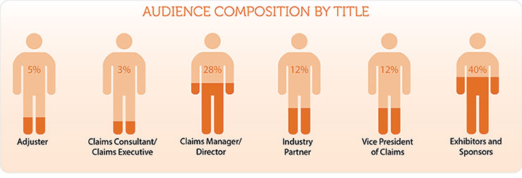
Educational topics are selected and developed by the NAMIC Claims Conference Planning Committee, which is a group of professionals who have volunteered to serve in an advisory function for the conference. Each session is guided by a pair of committee members; we call them Session Chairs. You will work throughout the process with the Session Chairs and the professional NAMIC staff member, Amy Thornburg, who is the conference planner.
Please complete the following sections in entirety and we look forward to reviewing your proposal.

Session Title (subject to editing by NAMIC):
Speaker Name as it should be listed within the materials:
Speaker Address with City and State:
Speaker contact email:
Speaker phone number:
Speaker Social Media:
- Twitter handle:
- Facebook page:
- Other:

Session Description (subject to editing by NAMIC): (4-5 sentence description about the session)

Key Learning Objectives: (3-4 items which the audience will learn from the session)

Ideas for Audience Participation (describe in 50 words or less or in a bulleted list how you would involve the audience and make the session interactive, lecture-style is often not the preferred way of learning for adults)

Paragraph Bio (subject to editing by NAMIC): (3-4 sentences which describes your expertise and/or background. Feel free to add something unique about yourself!)

Video Link (not required but viewed favorably, YouTube videos welcome too):

Brief history of previous speaking engagements and/or references from previous speaking engagements:

Honoraria and/or Expense Request:

